I use the following 3 switches.
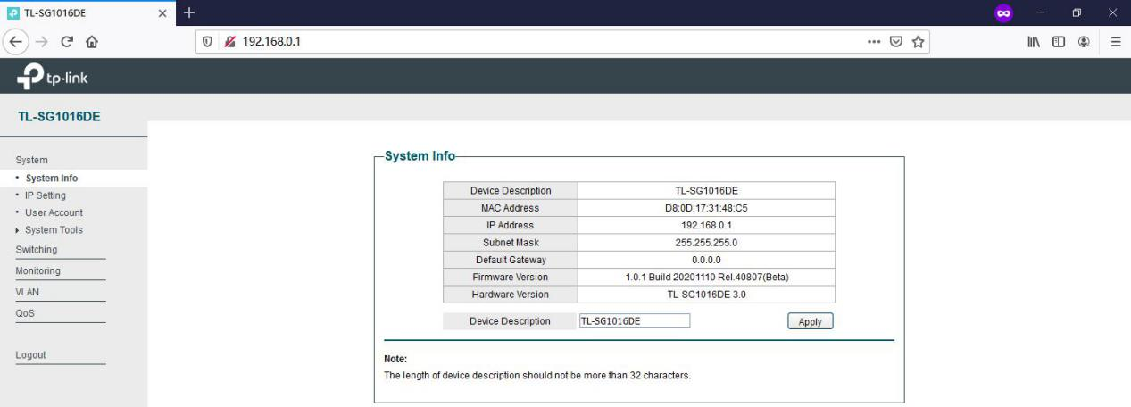
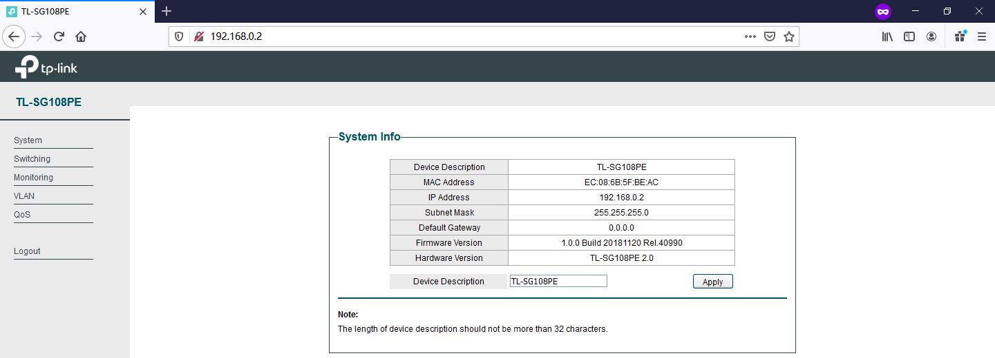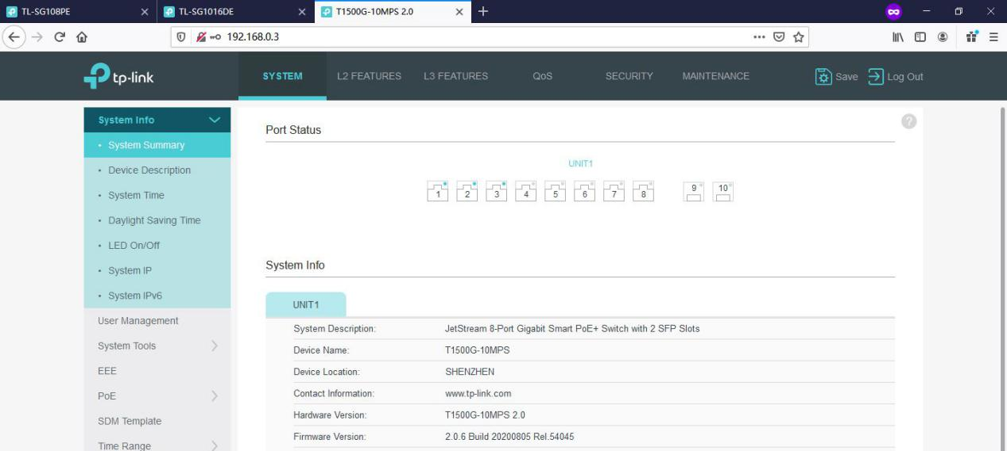
Configure the LAG Group on the 3 switches as below:
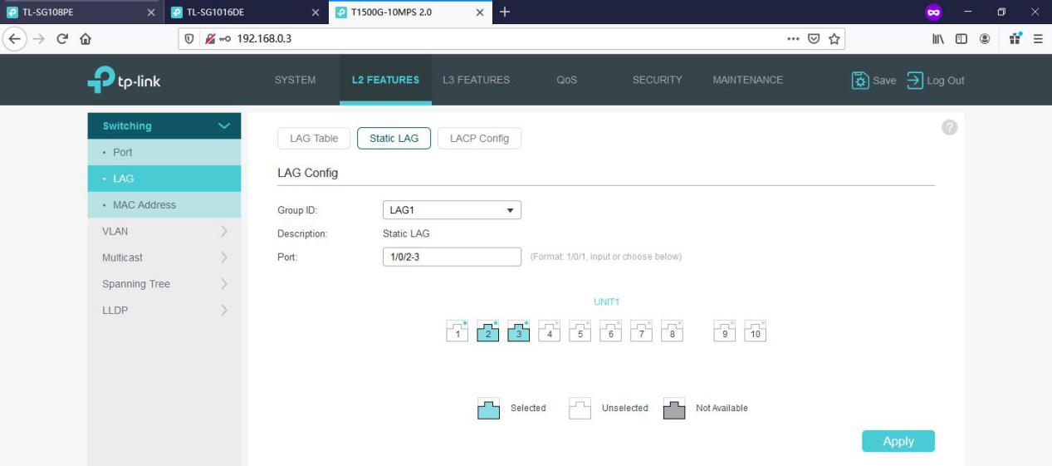

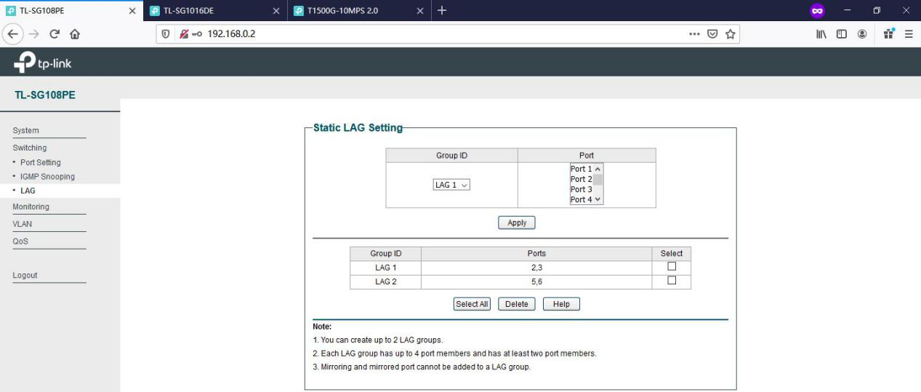

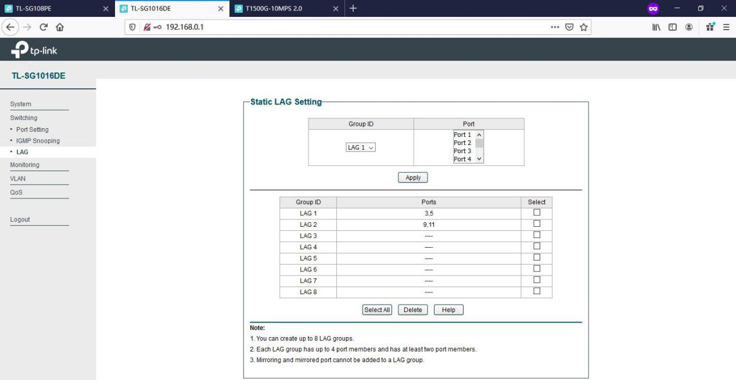

With the above configuration, I testes the following connection, no any other devices connected:
TL-SG108PE(LAG1) ---(LAG1)TL-SG1016DE(LAG2) ---(LAG1)T1500G-10MPS---one PC
TL-SG108PE(LAG1) ---(LAG2)TL-SG1016DE(LAG1) ---(LAG1)T1500G-10MPS---same PC
TL-SG108PE(LAG2) ---(LAG2)TL-SG1016DE(LAG1) ---(LAG1)T1500G-10MPS---same PC
TL-SG108PE(LAG2) ---(LAG1)TL-SG1016DE(LAG2) ---(LAG1)T1500G-10MPS---same PC
No loop prevention, all LEDs are acting normally, ping to the switches respectively is successful.

Exchange the TL-SG108PE and TL-SG1016DE, test the following connection:
TL-SG1016DE(LAG2) ---(LAG1)TL-SG108PE V2(LAG2) ---(LAG1)T1500G-10MPS ---same PC
TL-SG1016DE(LAG2) ---(LAG2)TL-SG108PE V2(LAG1) ---(LAG1)T1500G-10MPS ---same PC
TL-SG1016DE(LAG1) ---(LAG2)TL-SG108PE V2(LAG1) ---(LAG1)T1500G-10MPS ---same PC
TL-SG1016DE(LAG1) ---(LAG1)TL-SG108PE V2(LAG2) ---(LAG1)T1500G-10MPS ---same PC

Still the same, no loop prevention, all LEDs are acting normally, ping to the switches respectively is successful.

