Screen prints as request
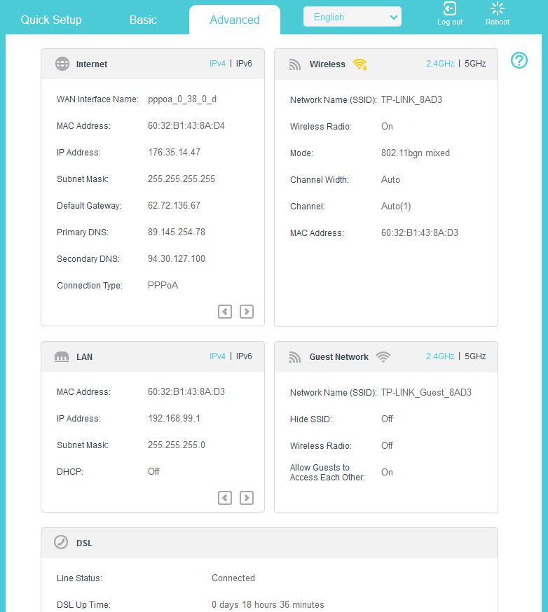
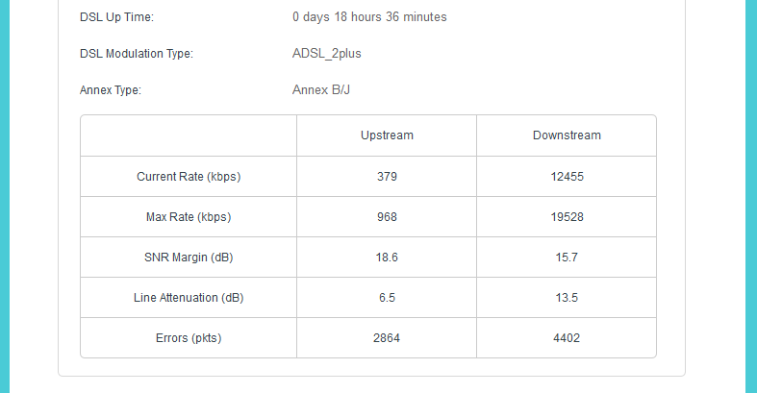

PPTP Setup – changed the 10. Range now. PC’s / NAS on 192.168.1.225, 226 and NAS 220
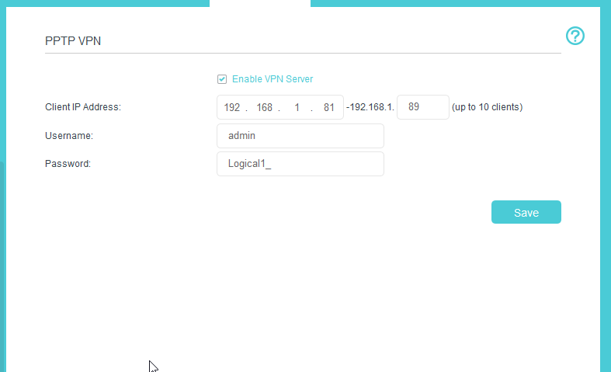
No default gateway or subnet mask options
When connected to via PPTP VPN I notice Gateway is not set (well 0.0.0.0)

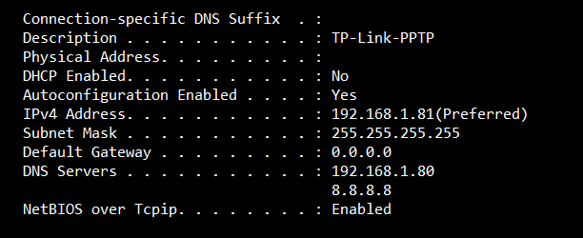
Not sure where the 192.168.1.80 DNS Server is coming from
I can access Router when connected remotely – I set the external port to 8080 so 192.168.99.1:8080
But its VERY slow
Client machine I’m connecting from to the VPN Server becomes extremely slow when connected to VPN.
